Git : Git is Version control system :

git init

then create the any file with any contents using GUI base or command prompt and in git terminal check the status
git status
git add filename.extension add the file from file system to stagging area
or
git add . all files and folder present in current directory
git commit -m “task done” it push you task to local repository.

if you get any error message about author details
git config --global user.name “Akash”
git config --global user.email “akash@gmail.com”

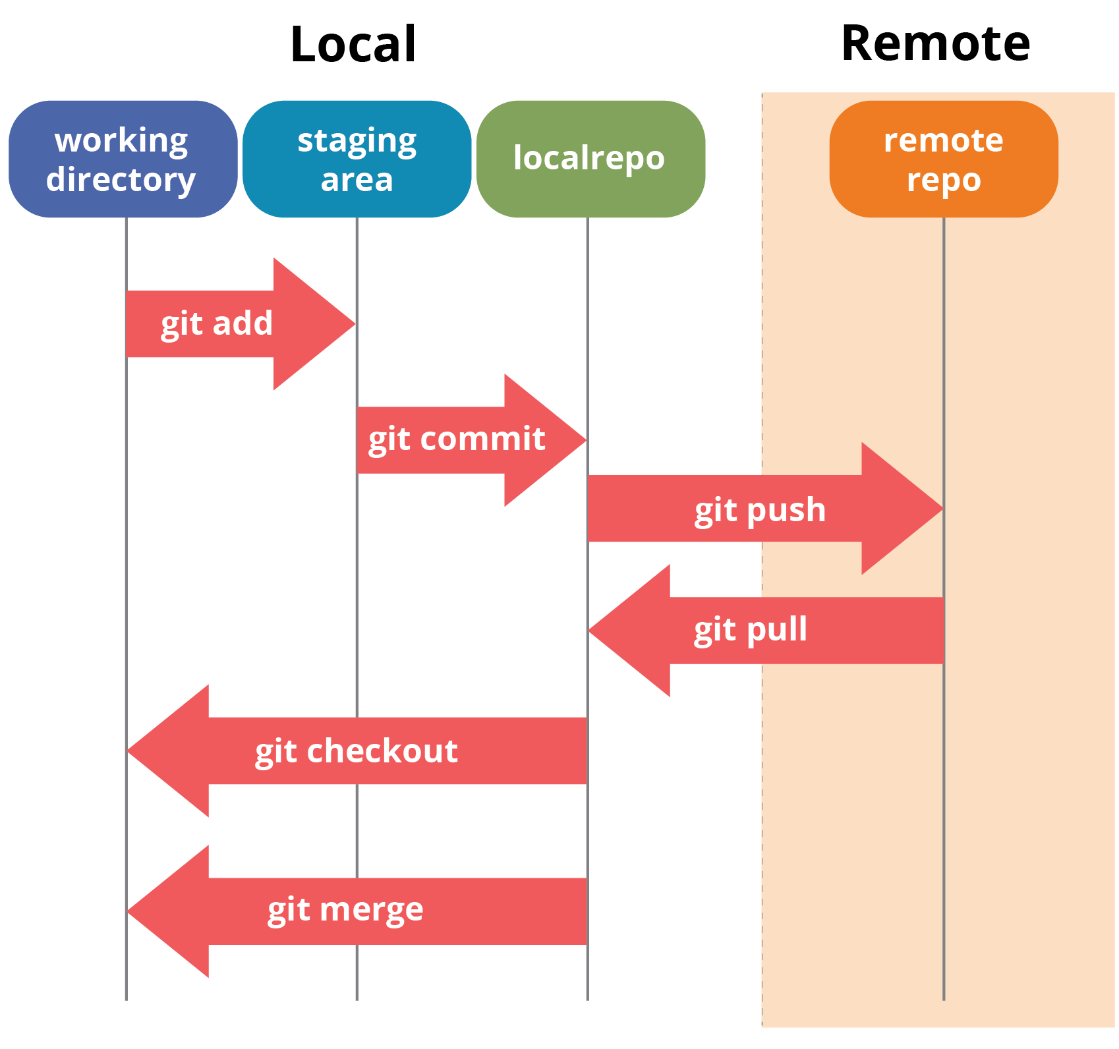

Git branch : git branch is like a pointer which hold more than one commit details.
By default git create default branch as master or main.

To view all branches present in current directory
git branch
creating new branch
git branch branchname
to switch one branch to another branch
git checkout branch_name
or
git switch branch_name

